***Geographical Spread of Cultivated Area Across States***

Submitted by

Anuradha Jha

Registration No. : 12308887

Section : K23GF

Course Code : INT217

Under the Guidance of

Sandeep Kaur

UID: 23614

Discipline of CSE/IT

Lovely School of Computer Science and Engineering Lovely Professional University, Phagwara

CERTIFICATE

This is to certify that Anuradha Jha bearing Registration No. 12308887 has completed the INT217 project titled, **“Geographical Spread of Cultivated Area Across States”** under my guidance and supervision. To the best of my knowledge, the present work is the result of his/her original development, effort, and study.

Sandeep Kaur

Professor

School of Computer Science and Engineering

Lovely Professional University Phagwara, Punjab.

Date: 10-04-2025

DECLARATION

I, Anuradha Jha, student of BTech under CSE/IT Discipline at Lovely Professional University, Punjab, hereby declare that all the information furnished in this project report titled **“Geographic Spread of Cultivated Area Across States”** is based on my own intensive work and is genuine.

Date: 10-04-2025

Registration No.: 12308887 Name of the student: Anuradha Jha

ACKNOWLEDGEMENT

I would like to express my sincere gratitude to my faculty and department for their constant guidance and encouragement throughout the successful completion of this minor project titled **“Geographical Spread of Cultivated Area Across States.”**

I also extend my heartfelt thanks to Lovely Professional University for providing the necessary resources, infrastructure, and learning environment that enabled me to carry out this project effectively.

Anuradha Jha

B.Tech CSE

Contents

1. Introduction 7
2. Source of Dataset 8
3. Sample Dataset 9

. 9

1. Dataset Preprocessing 10
2. Dashboard 11
3. Analysis on dataset 13

Objective 1: Top 5 States with High Production 13

* 1. General Description: 13
  2. Specific Requirements: 13
  3. Analysis Results 13
  4. Visualization 13

. 14

Objective 2: Year-Wise Trend of Total Agriculture Production 15

1. General Description: 15
2. Specific Requirements: 15
3. Analysis Results 15
4. Visualization 15

Objective 3: Crop-Wise % Share of Total Cultivated Area 17

1. General Description: 17
2. Specific Requirements: 17
3. Analysis Results 17
4. Visualization 17

Objective 4: Top 5 Crops by Average Yields 19

1. General Description: 19
2. Specific Requirements: 19
3. Analysis Results 19
4. Visualization 19

Objective 5: State Contribution to National Production 21

1. General Description: 21
2. Specific Requirements: 21
3. Analysis Results 21
4. Visualization 21

Objective 6: Production Efficiency of Crops 23

1. General Description: 23
2. Specific Requirements: 23
3. Analysis Results 23
4. Visualization 23

Objective 6: Area and Production Over Time 24

1. General Description: 24
2. Specific Requirements: 24
3. Analysis Results 24
4. Visualization 24
5. Conclusion 25
6. Future Scope 26
7. Linkedln 28
8. References 29

## Introduction

Agriculture is the backbone of the Indian economy, contributing substantially to livelihoods, food supply, and regional development. Understanding how cultivated land is geographically distributed across states is critical for efficient land use planning, policy formulation, and sustainable agricultural practices. Due to the large and varied nature of agricultural data, extracting actionable insights can be complex without effective visual and analytical tools.

In this project, a detailed Excel-based dashboard titled **“Geographical Spread of Cultivated Area Across States”** has been developed to analyze and visualize state-wise, year-wise, and season-wise trends in cultivated land across India. The primary aim of this dashboard is to transform vast datasets into interactive and visually intuitive charts that support better analysis and decision-making.

The dashboard enables users to:

* + Track cultivated area trends across multiple years and states.
  + Compare seasonal variations in land use across different regions.
  + Identify top states by total cultivated land.
  + Analyze average cultivation intensity and patterns.
  + Focus on regional hotspots with high or low agricultural land coverage.

Interactive slicers and filters allow users to explore the data based on seasons, years, and crops, making the insights highly customizable. Excel tools like PivotTables, PivotCharts, and slicers have been utilized to create a responsive and insightful user experience.

This project showcases Excel’s potential as a powerful tool for agricultural data visualization, highlighting the significance of geographic insights in farming analytics. It supports smarter, data-driven decisions and sets the stage for future innovations in land use forecasting, resource allocation, and policy analysis.

## Source of Dataset

The dataset used in this project has been sourced from the official Government of India open data platform — [data.gov.in](https://data.gov.in). This portal offers publicly accessible datasets from various sectors such as agriculture, health, education, and economy, promoting open research and data-driven decision-making.

For this project, the dataset titled **“District-wise, Season-wise Crop Production Statistics”** was selected, as it contains detailed records of cultivated area across Indian states and seasons. The data is categorized by agricultural seasons like Kharif, Rabi, and Zaid, and includes essential attributes such as state, district, crop type, season, year, area under cultivation (in hectares), and production. This makes it an ideal resource for studying the spatial distribution and temporal trends of cultivated land in India.

³ **Dataset Link:** <https://ndap.niti.gov.in/dataset/6162>

Key features of the dataset:

* **Attributes:** State, District, Crop, Season, Year, Area (in hectares), Production (in tonnes)
* **Coverage:** Multi-year data across major agricultural states of India
* **Format:** CSV
* **Purpose: T**o enable analysis of cultivated land distribution, seasonal land use, and geographic cultivation patterns.

The dataset was downloaded in CSV format and prepared using Microsoft Excel. Data cleaning and formatting were done to enable accurate analysis and the creation of an interactive dashboard focused on cultivated area distribution across Indian states.

## Sample Dataset

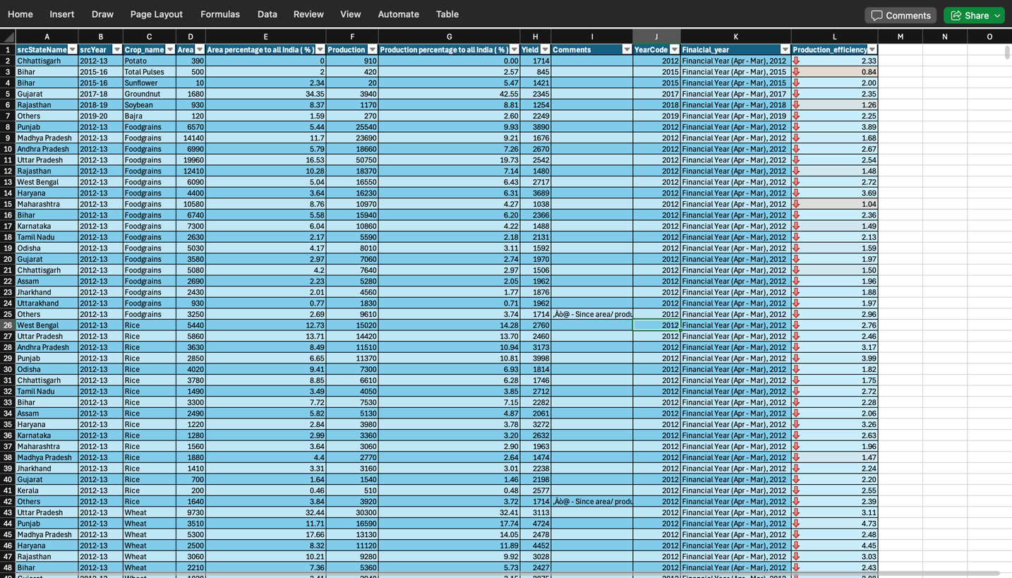

## Dataset Preprocessing

Before carrying out any analysis or developing visualizations, the dataset was thoroughly preprocessed to ensure data accuracy, consistency, and usability. Preprocessing plays a vital role in transforming raw agricultural data into a structured format suitable for effective dashboard creation and interpretation.

Steps Taken for Preprocessing:

1. Data Cleaning:
   * Removed rows that were blank or contained null values.
   * Standardized naming conventions for states and seasons to avoid duplication.
   * Corrected inconsistencies and spelling errors in state and district names.
2. Handling Missing Values:
   * Excluded rows with missing area values to maintain accuracy in cultivated area analysis.
   * Verified that each column had complete and interpretable entries.
3. Data Type Conversion:
   * Converted the 'Area' column to appropriate numeric types (float/int).
   * Ensured textual fields such as State, Season, and Year were properly formatted.
4. Derived Column Creation:
   * Filtered only necessary fields like State, Year, Season, and Area for focused analysis
   * Aggregated total cultivated area per state and per season using PivotTables.
5. Data Formatting for Excel:
   * Saved the final cleaned dataset in .xlsx format.
   * Created PivotTables and Pivot Charts on separate sheets for clarity.
   * Added interactive slicers for State, Year, and Season to enhance user control.

This structured preprocessing made the dataset dashboard-ready and ensured reliable, clear visual insights into how cultivated land is spread across India’s geographic regions.

# Dashboard

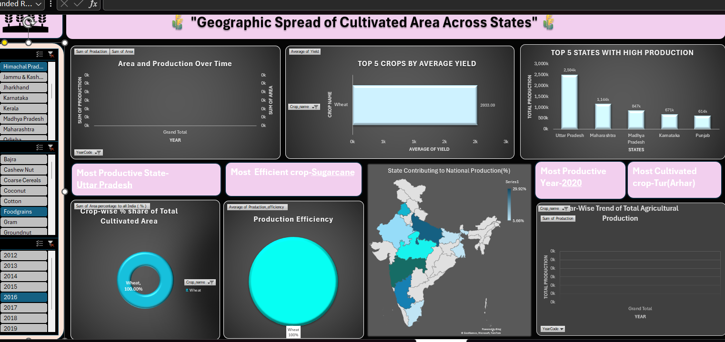

Interactive Crop Production Dashboard

The dashboard developed in this project presents key insights on the distribution of cultivated land across Indian states using intuitive visualizations. It highlights critical dimensions of agricultural land use through the following features:

* + **State-wise Cultivated Area:** Bar charts display how much land each state dedicates to agriculture.

**Year-wise Trends:** Line graphs reveal how the total cultivated area has changed over the years. **• Season-wise Land Usage:** Column charts compare area under cultivation during Kharif, Rabi, and Zaid seasons. **• Top Cultivating States:** Visuals rank the top 5 or 10 states based on total cultivated area.  
**• Regional Focus:** Charts show variations in cultivated area across geographical zones.  
**• Dynamic Slicers:** Filters allow users to interactively view data by state, year, and season.

This dashboard was designed using Microsoft Excel’s PivotTables, PivotCharts, and slicers, making it dynamic and easy to navigate. It enables users to explore geographic patterns and trends in cultivated area with precision and interactivity.

## Analysis on dataset

##### Objective 1: Top 5 States with High Production

###### General Description:

This objective identifies the top 5 states in India that have recorded the highest total agricultural production. Highlighting these states helps in recognizing regional leaders in agricultural output and understanding geographic concentration of food production.

###### Specific Requirements:

Use a PivotTable to sum total production by state and sort the results in descending order. Extract the top 5 entries and visualize them using a column chart. Add slicers for crop and year to allow interactive filtering and comparison across different periods.

###### Analysis Results:

The results show that states like Uttar Pradesh, Madhya Pradesh, and Punjab consistently appear among the top contributors in terms of total crop production. These states benefit from favorable climate, extensive agricultural land, and high cultivation intensity.

###### Visualization:

A column chart titled **“Top 5 States with Highest Agricultural Production”** was created.  
Slicers for crop and year enable users to dynamically explore different combinations and observe changes in production rankings over time.

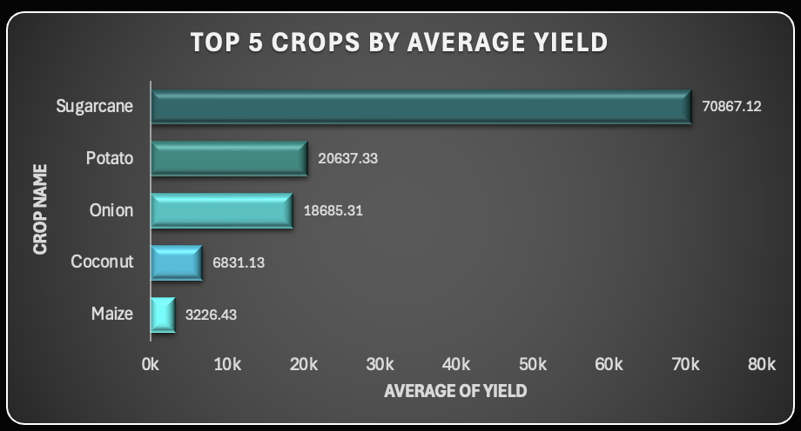

#### Objective 2: Year-Wise Trend of Total Agricultural Production

###### General Description:

This objective aims to explore how the total agricultural production in India has varied over the years. Year-wise analysis provides valuable insights into the overall growth, decline, or stability in production, and helps evaluate the influence of climatic events, agricultural reforms, and technological advancements on output levels.

###### Specific Requirements:

Aggregate total crop production year-wise using a PivotTable. Visualize the trend using a line chart to depict the progression over time.  
Add slicers for filtering by crop and state for comparative study. Ensure clear chart formatting including proper titles, axes, and gridlines for better readability.

###### Analysis Results:

The trend revealed fluctuations across years, with notable peaks in certain periods reflecting strong agricultural output. Years such as 2012 and 2016 showed high production, whereas others reflected a decline likely due to environmental factors or economic challenges. The most recent data may show lower values due to incomplete reporting.

###### Visualization:

A line chart titled **“Total Agricultural Production by Year”** was created.  
Slicers for crop and state were added for interactivity. This visualization enables users to monitor how production performance has evolved over time and under different crop scenarios.

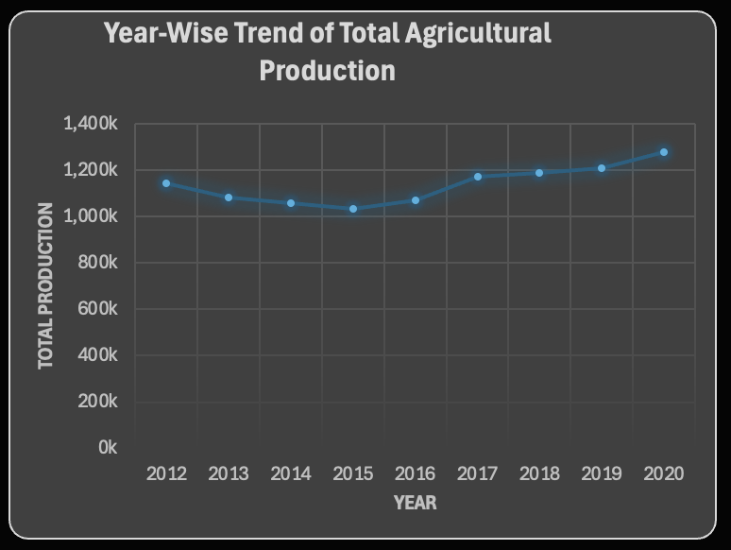

#### Objective 3: Crop-wise % Share of Total Cultivated Area

###### General Description:

This objective analyzes how the total cultivated area is distributed among different crops. Understanding crop-wise land allocation helps evaluate crop preferences, agricultural priorities, and resource usage across regions and seasons. This insight is essential for optimizing land planning and promoting crop diversification strategies.

###### Specific Requirements:

* + Use a PivotTable to calculate total cultivated area for each crop.
  + Derive each crop’s percentage share of the total area.
  + Display the results using a pie chart or horizontal bar chart.
  + Apply slicers for filtering by state, year, and season to make the dashboard interactive and responsive.

###### Analysis Results:

The analysis revealed that crops like rice and wheat occupy the highest percentage of cultivated land across multiple states. Horticultural or niche crops occupied a smaller share but were dominant in specific regions. This breakdown provides an effective way to evaluate land utilization by crop category and supports planning for sustainable cultivation.

###### Visualization:

A bar chart titled **“Crop-wise % Share of Total Cultivated Area”** was created.  
Slicers for state, year, and season were added to enable interactive filtering. The visual dynamically updates based on the selected filters and presents a clear picture of crop-level land distribution.

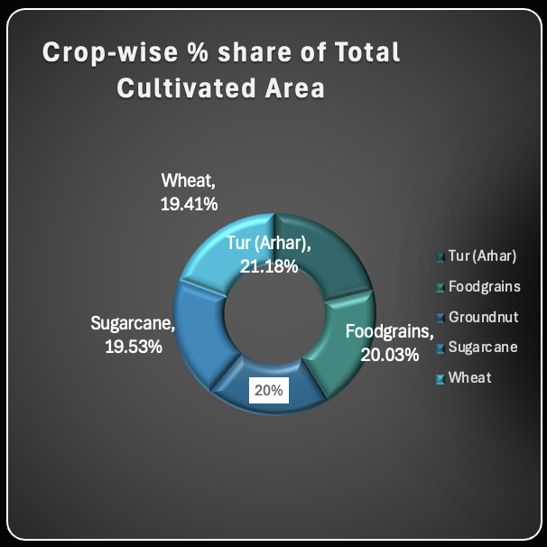

#### Objective 4: Top 5 Crops by Average Yield

###### General Description:

This objective focuses on identifying the top 5 crops with the highest average yield, calculated as production per unit of cultivated area. Analyzing average yield provides valuable insights into crop efficiency, highlighting which crops offer better output relative to the land used. This helps in promoting high-yield crops and optimizing agricultural productivity.

###### Specific Requirements:

* + Use a calculated column to derive yield using the formula: Production ÷ Area.
  + Create a PivotTable summarizing average yield for each crop across all states.
  + Sort and display the top 5 crops using a horizontal bar chart.
  + Add slicers for filtering based on state and year to make the visualization interactive.

###### Analysis Results:

The results revealed that crops like sugarcane, banana, and maize consistently showed high average yields across multiple states. These crops are generally associated with high-input farming and better irrigation access. In contrast, coarse grains had lower average yield, often reflecting marginal land cultivation.

###### Visualization:

A bar chart titled **“Top 5 Crops by Average Yield”** was created.  
Interactive slicers for state and year allow users to filter results based on different parameters. The visual helps stakeholders quickly identify the most productive crops under current conditions.



#### Objective 5: State Contribution to National Production

###### General Description:

This objective focuses on evaluating how much each state contributes to the overall agricultural production at the national level. Understanding these contributions helps highlight high-performing states, supports policy targeting, and brings attention to regional imbalances in agricultural output.

###### Specific Requirements:

* + Create a PivotTable to sum total production grouped by state.
  + Calculate each state’s contribution as a percentage of the national total.
  + Use a clustered column chart to visualize the contributions comparatively.
  + Add slicers for year and crop to allow exploration of patterns across time and product categories.

###### Analysis Results:

The analysis highlighted that states such as Uttar Pradesh, Madhya Pradesh, and Maharashtra account for a large portion of national agricultural production. Other states, particularly in the northeast or arid regions, contribute comparatively less. These insights help identify states with high agricultural potential and regions requiring investment or support.

###### Visualization:

A clustered column chart titled **“State-wise Contribution to National Production”** was created.  
Slicers for year and crop allow users to filter and explore trends dynamically. The chart clearly distinguishes between high and low contributing states using consistent color formatting for clarity.

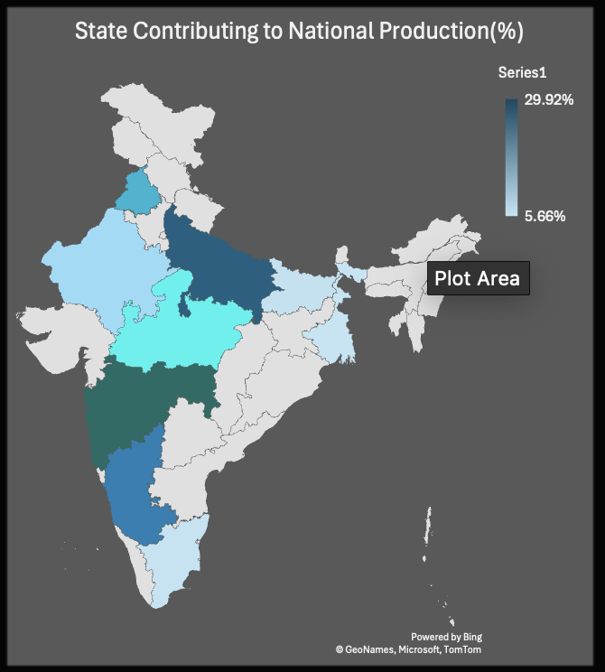

##### Objective 6: Production Efficiency of Crops

###### General Description:

This objective focuses on analyzing the production efficiency of different crops, calculated as the yield per hectare. Rather than simply comparing total production, this analysis emphasizes how effectively land is utilized across various crops, supporting decisions around optimal crop selection and resource allocation.

###### Specific Requirements:

* + Calculate yield using the formula: Production ÷ Area for each crop.
  + Create a PivotTable grouped by crop to display average yield values.
  + Use a horizontal bar chart to compare crop efficiencies.
  + Integrate slicers for state and year to allow dynamic filtering and contextual analysis.

###### Analysis Results:

The analysis showed that crops like sugarcane, banana, and maize demonstrated high production efficiency, while some cereals and pulses had lower yield rates. This variation highlights the impact of crop type, climate, and input quality on efficiency, and informs better land use planning.

###### Visualization:

A horizontal bar chart titled **“Crop-wise Production Efficiency (Yield per Hectare)”** was created.  
Slicers for state and year were added to allow targeted filtering. The visualization offers a clear comparison of how efficiently different crops convert land into output.

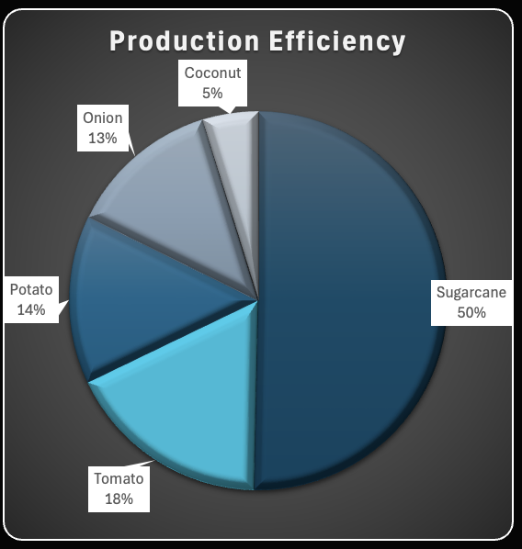

##### Objective 7: Area and Production Over Time

###### General Description:

This objective aims to examine how both cultivated area and total crop production have changed over the years. By analyzing these two metrics together, users can assess whether increases in production are due to expanded cultivation or improved efficiency, and how external factors may have influenced agricultural trends.

###### Specific Requirements:

* 1. Create two PivotTables to separately aggregate Area and Production year-wise.
  2. Visualize both metrics on a dual-axis line chart for comparison.
  3. Add slicers for state and crop to support detailed filtering.
  4. Ensure chart formatting clearly distinguishes the two lines and enhances readability.

###### Analysis Results:

The analysis revealed that while cultivated area remained relatively stable in some years, production showed greater variation—indicating changing efficiency levels. In certain states, increased production was achieved without a significant rise in area, suggesting improved agricultural practices or favorable weather conditions.

###### Visualization:

A dual-axis line chart titled **“Cultivated Area vs. Production Over Time”** was created.  
Slicers for crop and state were used to enable interactive analysis. The chart visually demonstrates the relationship between area and output, helping identify trends in productivity and land utilization.

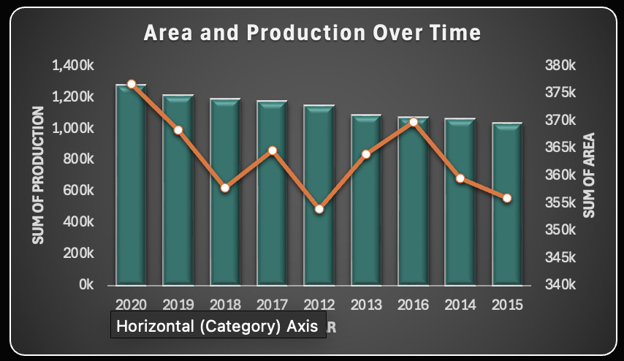

## Conclusion

The project titled **“Geographic Spread of Cultivated Area Across States”** aimed to simplify the interpretation of large-scale agricultural datasets by presenting clear, visual insights into the spatial distribution of cultivated land across India. By using Microsoft Excel tools such as Pivot Tables, Charts, and Slicers, the project successfully converted complex data into an interactive and easy-to-navigate dashboard.

* + This dashboard enables users to analyze and compare cultivated area data across various dimensions such as state, year, season, and crop. Key functionalities include:
  + Visualizing each state’s contribution to total cultivated area, identifying leading agricultural regions.
  + Monitoring year-wise trends in cultivated land to track expansion or decline over time.
  + Filtering data by season (Kharif, Rabi, Zaid) to assess seasonal land use patterns.
  + Comparing average yield and efficiency metrics by crop, helping inform land allocation strategies.
  + Highlighting the top crops by area or yield, guiding decisions around cultivation planning.
  + Exploring the relationship between area and production, offering insights into agricultural productivity.

The use of consistent formatting, color schemes, and interactive slicers enhances both the visual appeal and usability of the dashboard, allowing users to make informed decisions based on reliable, real-time insights.

This project illustrates the potential of Excel-based dashboards in agricultural data science, supporting smarter resource management and regional planning. The methodology is adaptable and can be extended to integrate live data sources, advanced analytics, or geographic mapping tools in future updates.

.

## Future Scope

The current version of the **“Geographic Spread of Cultivated Area Across States”** dashboard offers valuable insights into cultivated land distribution, seasonal usage, state-wise trends, and crop-wise area allocation. However, there is significant potential to enhance the dashboard further for better usability, depth, and impact:

**Real-Time Data Integration**  
Integrating live agricultural datasets via APIs or web scraping could enable the dashboard to reflect the most current cultivation data, replacing static historical views with real-time insights.

**Automated Refresh Mechanism**  
Automating the data update process will ensure the dashboard remains accurate and up-to-date without manual intervention, especially important when working with frequently changing datasets.

**Interactive Geo-Mapping**  
Incorporating geographic maps to visualize state-wise or district-level cultivated area can improve spatial awareness and enhance the dashboard’s visual engagement and clarity.

**Advanced Filters and Drill-Down Analysis**  
Introducing multi-level filters would allow users to explore specific crop types, regional trends, or time-based comparisons for more detailed and contextual analysis.

**Predictive Analysis**  
Connecting the dashboard to predictive models using tools like Python or R could forecast future cultivation patterns based on historical land usage and environmental trends.

**Web-Based Dashboard Version**  
Migrating the dashboard from Excel to platforms like Power BI, Tableau, or Python Dash can make it more accessible, interactive, and shareable online, with advanced capabilities.

**Mobile Compatibility**  
Designing a responsive version of the dashboard would allow mobile users to easily access and interpret cultivated area trends and insights while on the move.

**User Documentation and Help Guide**  
Adding built-in help tabs or tooltips can make the dashboard more intuitive, especially for first-time users, ensuring they understand how to interact with slicers and interpret visualizations.

By implementing these features, the dashboard can evolve into a comprehensive agricultural analysis platform supporting farmers, planners, researchers, and policymakers

.

### Linkedln:

<https://www.linkedin.com/posts/anuradha-jha-299765294_exceldashboard-datavisualization-agricultureanalytics-activity-7317853778982981633-wHKx?utm_source=share&utm_medium=member_desktop&rcm=ACoAAEdNnVUB4lDCCu8gurdIP_ye1wKnLYaH5Aw>

### References

1. Government of India, Ministry of Agriculture and Farmers Welfare, , [Online]. Available: <https://www.data.gov.in/catalog/district-wise-season-wise-crop-production-statistics-0> [Accessed: Apr. 2025].
2. Microsoft, *"Create a PivotTable to analyze worksheet data"*, Microsoft Support. [Online]. Available: <https://support.microsoft.com/en-us/excel> [Accessed: Apr. 2025].

### 